Template for Departmental Activity Report

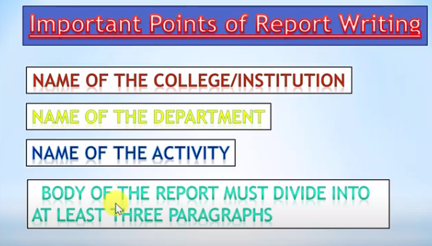
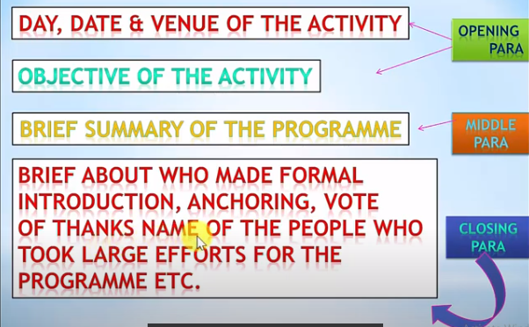
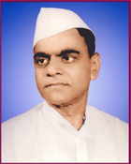
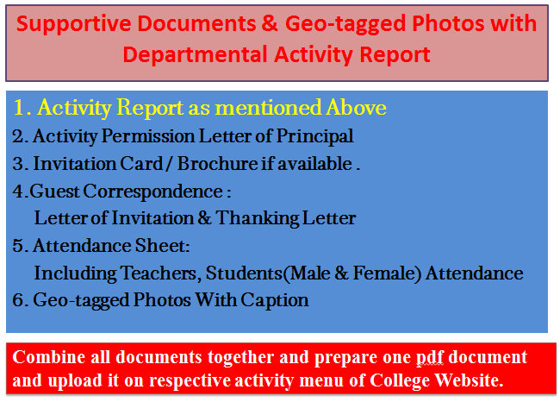
Janata Shikshan Sanstha’s
Kisan Veer Mahavidyalaya,Wai
Department of N.C.C.
Report
A Demonstration of Domestic Gas
A “Demonstration of Domestic Gas” the program, was jointly organized by the department of NCC and Distaster management committee of the college on 25-11-2020. The expert team of Bharat Gas was invited for the demonstration. The team cleared doubts regarding use of domestic gas. The Principal Dr. I.F. Pailwan was the chair person of the program. Dr. H. D. Kanse anchored the programme. Lieutenant Sameer Pawar offered the vote of thanks. 100 cadets and 150 students attended the program.

Dr. I. F. Pailwan Lieutenant Sameer Pawar
College Seal
Principal NCC Officer
Kisan Veer Mahavidyalay, Wai NCC Unit
2. Activity Permission Letter of Principal

Paste the PDF

4. 4.Guest Correspondence:
Letter of Invitation & Thanking Letter

Paste the PDF
3. Invitation Card / Brochure if available

Paste the PDF

Combine all documents together and prepare one pdf document and upload it on respective activity menu of College Website.
Caption
Caption
Paste the PDF
Paste the PDF
Caption
Caption
Paste the PDF
Paste the PDF
5. Geo-tagged Photos With Caption

Paste the PDF
5. Attendance Sheet:
Including Teachers, Students
(Male & Female) Attendance

